Descriptions:

This text file covers these versions of software:
dtmf_gen_1_3_2.src: Demonstrates DTMF generation
dtmf_det_2_03: Demonstrates DTMF detection
simple_fsk_rx.src Demonstrates V.23 detection
simple_fsk_tx.src Demonstrates V.23 generation
CID_2_0.src: V.23 detection, and Caller ID parsing.
sx_modem_3_51.src: Half Duplex V.23 modem. Also has two simplex test modes, TX only and RX only.
sx_modem_3_62.src: Modem operation is the same as sx_modem_3_51, but without the simplex modes. Also adds a simplified AT command set and ring detection.
sx_all_comms_1_02: This program demonstrates all of the above modules in one piece of firmware, except for the simplex modes of V.23 communication.
Note: Certain Revisions of the demonstration boards need a small software change. The polarity of the in_out pin may need to be reversed:
setb in_out → clrb in_out and clrb in_out → setb in_out

For SX DTMF DEMO boards which are not marked rev 1.4, clearing in_out enables the output and setting in_out disables the output, and vice versa for the boards which are marked rev 1.4.

INSTRUCTIONS:

Skip Section (1) if you don't need to program the SX devices.

- Connecting and programming the board with the desired source file

a.) Make sure that power is not applied to the board
b.) Locate the four-pin header for programming and debugging.
i.) Put Parallax's SX-Key on the header, with the labels lined up.
-Header is labeled: Vss, Vdd, OSC2, OSC1.
ii) Connect the SX-Key to the DB9 connector of the PC's serial port.
c.) Plug power supply (>7V @ 300+ma, positive center) into plug.
- Universal power supplies usually have the right connector.
d.) Execute the SX-Key development tool software.
-Version 1.0 is available from Parallax's website at http://www.parallaxinc.com
e.) In the top menu, go to "File", "Open" and choose the desired .src file.
Go to "Run", "Program."
-If you find you are getting 'chip connect failed' messages, update your version of SX-Key software. Software updates are available from www.parallaxinc.com.
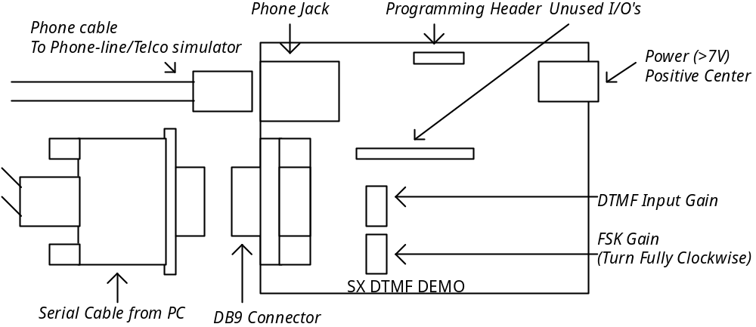
Figure 1: Modem Board Diagram

- Connecting the board and running the demo:

For Demo Purposes, a Telephone-Line simulator or regular phone lines can be used.

a.) Connect one end of a DB9 serial cable to the board and the other end to the PC's DB9 connector (note the COM port connected)
b.) Connect a phone cable to the phone jack of the modem board and to the Telephone Simulator/Phone Line
i.) Power up the Telephone Simulator, if connected
c.) Execute Hyperterminal program
i.) Settings: See the individual instructions for each piece of software below
d.) Plug regulated power supply (>7VDC 300+mA) into plug. Note that Green LED light blinks.
e.) Press 'RESET' button to get the prompt on the terminal screen.

(3) Demo Programs

When the prompt appears

dtmf_gen_1_3_2.src: Press 'd' to start dialing. Type characters such as 1, 2, 3 or * or # on the keyboard and the modem board will dial each of these characters for a 100ms duration.
HYPERTERMINAL SETTINGS: 19200, N, 8, 1

dtmf_det_2_0_2.src: Press 'd' for DTMF Input. Start by calling the modem board. When the line starts ringing, press 'd' to enter input mode. Numbers pressed on the keypad of a connected touch-tone phone will appear on the screen.
HYPERTERMINAL SETTINGS: 19200, N, 8, 1

CID_2_0.src Call the board. Any received Caller-ID will be shown on the terminal screen.
HYPERTERMINAL SETTINGS: 1200, N, 8, 1

sx_modem_3_51.src: First press 'D' to dial from one of the boards. When you know the other board is ringing:
-Press 'F' on both boards and they will be able to talk to one another via half-duplex 1200-baud FSK.
-Press 'T' on one board and 'R' on the other and you can communicate in one direction at 1200baud. You must send from the transmitting board to the receiving board.
HYPERTERMINAL SETTINGS: 1200, N, 8, 1. UART/modem speed defineable in the code.

sx_modem_3_61.src: This version of code adds a small AT-Command set and ring detection to the mix. The commands for the AT command set are available from the command line simply by typing '?' and pressing enter and are as follows:

? =HELP
+++ =COMMAND MODE
ATO =DATA MODE
ATDT=DIAL
ATA =AUTO ANSWER
ATH =HANG UP
ATZ =INIT

For instance to dial a number from an inside line, you would type
ATDT 9,14083278888
And press <enter>

The modem will automatically switch to data mode. Once in data mode, all typed characters are sent via FSK to the receiving modem. To switch back to commmand mode from data mode, type '+++'. Once in command mode, you can hang-up, re-initialize, re-dial, etc. To get back to data-mode once in command mode without dialing or auto-answering, type 'ATO' and press <enter>
HYPERTERMINAL SETTINGS: 1200, N, 8, 1. UART/modem speed defineable in the code.

sx_all_comms_1_02.src: This version of code adds the dtmf detection and caller-id reception modules to the sx_modem_3_62 software. Two additional commands were added to run these modules. The commands for the AT command set are available from the command line simply by typing '?' and pressing enter and are as follows:

? =HELP
+++ =COMMAND MODE
ATO =DATA MODE
ATDT=DIAL
ATA =AUTO ANSWER
ATH =HANG UP
D = DTMF detection
C = Caller-ID detection

For instance to dial a number from an inside line, you would type
ATDT 9,14083278888
And press <enter>

The modem will automatically switch to data mode. Once in data mode, all typed characters are sent via FSK to the receiving modem. To switch back to commmand mode from data mode, type '+++'. Once in command mode, you can hang-up, re-initialize, re-dial, etc. To get back to data-mode once in command mode without dialing or auto-answering, type 'ATO' and press <enter>

To perform DTMF detection, call the modem board with a touch-tone phone, and press ‘D’ on the keyboard. The modem board will go off-hook. Once the modem board is off-hook, any digit pressed on the phone should be received by the modem board. To exit DTMF detection mode, press a key on the terminal and wait, or press the reset button on the DTMF demo board

To perform CALLER-ID detection, press ‘C’ and press <enter>. The modem will wait for caller-ID to be received, and will output the received caller-id to the screen. To exit caller-ID mode, press a key or hit reset on the DTMF demo board.

HYPERTERMINAL SETTINGS: 1200, N, 8, 1. UART/modem speed defineable in the code.
4.) Performing Specific Demo's

DTMF Input:

Use this software: dtmf_det_2_0_2.src. Follow the instructions to program the board.

To demo DTMF Input with the Telco Simulator:

-connect the demo-board to the simulator (party-line box) using a phone cable.
-connect a phone with touch-tone output to the simulator using a phone cable.
-connect the demo-board to the PC and to power as listed in part (2.) Set Hyperterminal to a baud rate of 19,200.
-press reset on the demo board to get the prompt.
-using the phone, dial the number of the line that the demo-board is connected to 7 to 10 times. (Some lines require seven digits, others require 10). When the LED on the line starts flashing, the line is ringing.
-press 'd' on the PC's keyboard to force the demo-board to pick up.
-dial numbers on the phone's keypad and watch the demo-board decode the tones.

To demo DTMF Input with a normal phone line:

-You will need 2 lines for this demonstration.
-Connect the demo board to the PC as noted in the instructions, but use a regular phone jack instead of the telco-simulator.
-Using a telephone on another line, dial the number of the line to which the demo-board is connected.
-When you can hear the line ringing on the phone, press 'd' on the PC's keyboard to put the demo-board into DTMF input mode.
-Dial numbers on the phone's keypad and watch the demo-board decode the tones.

DTMF Output

Use this software: dtmf_gen_1_3_2.src. Follow the instructions to program the board.

The best way to demo this software is probably to use an actual phone line with a phone attached. Connect the phone, and the demo-board, to the phone jack with a Y-jack. Pick up the phone and listen for the dial tone. Once a dial tone is received, press 'd' on the keyboard if using dtmf_gen_1_3_2.src. Now press keys on the keyboard to dial numbers. A good way to test DTMF output is to dial a bank payment hotline and pay a credit card bill using the touch-tone generation of the modem board.

Caller ID Detection

Use this software: sx_recv_mod_2_0.src. Follow the instructions to program the board.

You can either use the party-line box or a regular phone jack with caller-ID installed to demo this function. Connect the board as shown above and call it. The board will automatically display the caller-ID on-screen.

Modem Functions (DTMF Output/FSK Input/FSK Output)
Use this software: sx_modem_3_51.src. Two modems are required to perform the demo. They must both be connected to a PC with a keyboard (can use 2 com ports on the same computer.) Set the baud rate to 1200 baud, 8 data bits, no parity, and 1 stop bit. Connect both modems two the Telco Simulator or to outside phone lines. To dial with one of the modems, press 'd.' The modem will enter DTMF generation mode and the prompt will say 'begin typing…' Any numbers you type will be dialed. Once the line for the other modem is ringing, press 'f' to enter FSK I/O mode. Switch to the terminal screen for the other modem, and press 'f' to enter FSK I/O mode. This is a half-duplex modem mode, where the carrier is only transmitted while a character is being transmitted. Characters typed in one terminal window should appear in the other terminal window. Happy Typing!

Modem Functions (DTMF Output/FSK Input/FSK Output/Ring detection/AT Command Set)
Use this software: sx_modem_3_61.src. Two modems are required to perform the demo. They must both be connected to a PC with a keyboard (can use 2 com ports on the same computer.) Set the baud rate to 1200 baud, 8 data bits, no parity, and 1 stop bit. Connect both modems two the Telco Simulator or to outside phone lines. To dial with one of the modems, use the command 'ATDTnnnnnnnnn' and press enter, where the 'n's are the number to dial. The modem will dial the number and switch to data mode. On the other modem, use the 'ATA' command and press <enter>. The modem will switch do data mode when it detects a ring. This is a half-duplex modem mode, where the carrier is only transmitted while a character is being transmitted. Characters typed in one terminal window should appear in the other terminal window. Happy Typing!

